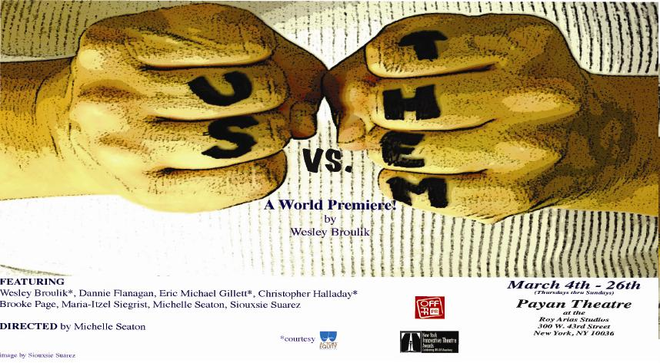

**The Happiest Meduim.com Review**

[**Us Vs. Them – We Are Both**](http://thehappiestmedium.com/2011/03/us-vs-them-we-are-both/)**, by Karen Tortora-Lee on March 23, 2011**

It’s rare that a six-degrees of separation type plot unravels as elegantly as ***Us vs. Them.***

The play, written by Wesley Broulik and directed by Michelle Seaton, begins simply enough at a road side rest stop where two sisters have pulled over to take a break, stock up on some fortifying snacks, and continue to get reacquainted after an apparently long estrangement.

It’s Christmas time and Nicole (Siouxsie Suarez) has made the trip to pick up her sister, Katy (Maria Itzel Siegrist), so that they can spend the holiday with their ailing mother. Throughout the conversation bits and pieces of their family’s history come out in a natural, off handed way, without the awkwardly phrased exposition some playwrights will fall back on which often tends to cripple a scene and take the audience right out of the moment. Rather, Katy and Nicole have the same awkward hesitancy which can flip into *don’t-try-it-because-I-know-exactly-how-to-press-your-buttons* and back again – something that can only come naturally from two sisters who grew up close and then grew apart.

From this initial scene we then move through a series of one-act vignettes which all stem from these two main branches; each building upon the last, each new story having been referenced in an earlier scene either as an important footnote or merely as background information. Therefore, when we next see Katy the timeline has shifted and we are (it seems) seeing her right before the road trip has occured when she is having a night with her romantic interest, the firefighter Kris (Christopher Halladay). From their scene together we find out a little bit more about the life Katy’s been leading since moving away; we also find out about Kris and his teen daughter Dannie (Dannie Flanagan). Much later, we will meet Dannie as she and her father deal head-on with Dannie’s leap into adulthood and her first serious sexual relationship.

Nicole’s story is similarly interwoven. We are brought back to a night that occurred before the road trip for her as well and we meet her partner, a vulnerable yet angry woman named T (Michelle Steaton), who is simultaneously hateful and heartbreaking. It’s obvious the two women have a lot of baggage that they brought into the relationship – problems with alcohol, trust issues, violent tendencies, but despite it all there is a real love between them that struggles to persevere. T speaks of a past that she needed to leave behind – and soon enough that past is unfolding before us as she goes back home for her own Christmas visit. We meet her father Eddie (Eric Michael Gillet), T’s sister Barbara (Brooke Page) and Barbara’s husband Howard (Welsey Broulik). Once we see this bunch suddenly T’s anger doesn’t seem so unprovoked anymore.

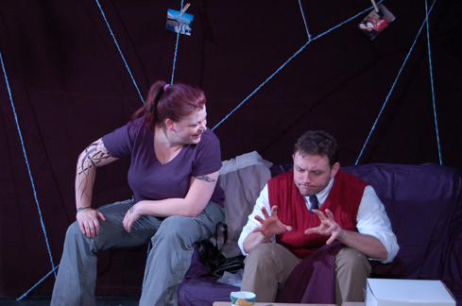 [](http://www.offoffonline.com/photos/3969.jpg)

Photos by Yolanda Suarez

T (Michelle Seaton) tries with all her might not to kill her idiotic, cheating brother in-law Howard (Wesley Broulik) | Photo by Yolanda Suarez

The character of Howard is played by playwright Broulik and to his credit he doesn’t cast himself as the hero of this piece – rather he’s probably the most deserving of a punch in the face. (I won’t give anything away, but in a family like this one, chances are good that he gets it). Howard is demeaning to all those around him, speaks to his wife Barbara as if she were stupid, and has very little respect for the family he’s married into. In fact, he does a great job of making some unlikeable people seem a lot more likeable when he’s around.

And that’s the gift of Broulik the playwright. In ***Us vs. Them*** he’s managed to make you dislike a character for their failings one moment and then staunchly defend them as they come under attack the next moment. His gift of being able to present a fully formed character is as sharp as his ability to create a wonderfully knitted storyline that walks right up to the edge of sentimentality without tipping over into the marsh of sappy. There will be moments during this show that will have you nodding in recognition, as well as recoiling in revulsion. And it is exactly because these human beings are frayed, chipped, scarred and wrinkled that they are so real. Sometimes they are Us. Sometimes they are Them. Throughout it all – they are worth seeing.

**Off-Off Online, Your comprehensive resource for New York City off-off-Broadway theatre listings and reviews.**

**The Dark Side of the Luna by Bess Rowen**

**Us vs. Them reviewed March 4, 2011**

*Us vs. Them* begins with a scene featuring a Big Gulp and a bi-lingual argument set against a backdrop of piped in Christmas music. This sets the tone for Dark Luna’s inaugural production, which is equal parts dark comedy and family drama. Though the concept of family dysfunction revolving around forced holiday togetherness is not completely original, it is the earnest acting of the eight member cast, and the cohesive design concept, that keeps *Us vs. Them* from seeming cliché.   
  
Written by Wesley Broulik, who also plays Howard, *Us vs. Them* has an engaging plot with well rendered characters and just the right amount of mystery. Yet, the play still manages to showcase the actors over the writing. In a series of scenes we are introduced to sisters Nicole (Siouxsie Suarez) and Katy (Maria Itzel Siegrist), firefighter Kris (Christopher Halladay) and his daughter Dannie (Dannie Flanagan), and Nicole’s girlfriend “T” (Michelle Steaton), T’s father Eddie (Eric Michael Gillet), T’s sister Barbara (Brooke Page) and Barbara’s husband Howard (Welsey Broulik). The links between these individuals and their stories are often re-contextualized as the play moves along.

I was continually drawn in by the relationships among the characters rather than the words themselves, which is clearly something that director (and actor) Michelle Seaton has fostered. Each actor not only connects and listens to his or her scene partners, but also maintains the same level of engagement in the creative scene changes. As the lights go down on the minimalist set, actors moving their props and set pieces stay in character, noticing and reacting to each other and the changes being made to the space.   
  
Ed Hill's set is decidedly simple and effective, consisting of a couch, a chair, and several cardboard boxes, while the walls are covered with a web of string, adorned with photographs of the various characters. Since the set itself creates an aesthetic of connectivity, these transitions serve to increase the audience’s sense of company and collectivity. In other words, when set against a stage decorated with a literal web, the in-character scene changes reaffirm the *Us vs. Them* mentality that exists in theater. Even in between scenes, the actors are onstage and in the web, while we are outside of it.

The moments in which actors are really looking and listening to each other are thrilling to watch. They happen here, though they rarely happen in monologues. The language seems to force the actors to push a little too hard, partially because of the amount of anger demanded in their monologues. Characters anger quickly and stay angry for large parts of scenes, causing the individual speeches to lack the dramatic arcs better rendered in the dialogue. For example, Nicole (Siouxsie Suarez) is less believable in her rant to her lover “T” (Michelle Seaton) about T’s drinking than she is seconds later in an impassioned dialogue about the nature of their relationship. Despite the occasional “thigh slap” or “sighing out” (two common acting tics) that accompanied some of these monologues, each and every cast member was able to engage me at certain moments. A standout scene occurs later in the play between Barbara (Brooke Page) and Dannie (Dannie Flanagan), who both give beautifully nuanced and genuine performances.   
  
In a play about the various forms of love and family, Dark Luna ends up showing us the importance of these themes both within the play and in the environment of a theater company. Both require hard work, love, and support. Though this play might not be profound in its written words, the production as a whole has a lot to offer. *Us vs. Them* is a journey to the dark side of the moon, with Dark Luna’s passionate actors and artistic/production team as guides, which is worth the sometimes bumpy ride.

Top of Form

Bottom of Form